

**Trimester: I/II/III Subject:** Basic Mechanical Engineering

**Name**: Krishnaraj Thadesar **Division:** 9

**Roll No.:** 109054 **Batch:** I3

**Experiment No.:** 1

**Name of the Experiment:** Demonstration of speed ratio in a power transmission system.

**Performed on:** 2nd September 2021

**Submitted on:** 9th September 2021

*Aim:*

To study power transmitting elements and determine the speed ratio of a simple gear train and to To understand the working of different power transmitting elements such as Couplings, Gears and  
Bearings.

*Theory:*

*Power transmission* is the movement of energy from its place of generation to a location where  
it is applied to perform useful work. Power is defined formally as units of energy per unit time.

*Power Transmitting Elements:* Machine elements used for transmitting the power are called as power transmitting elements. Various power transmitting elements are *gears*, shafts, clutches and brakes, pulleys, belts, chain, and sprocket.

*Gears:* One the most commonly used power transmitting elements is a gear. A gear is a toothed wheel that  
engages with another toothed wheel or with a rack in order to change the speed or direction of transmit  
motion.

They can be classified according to the relative positions of their shaft axes as follows:

1. *Parallel shafts:* Regardless of the manner of contact, uniform rotary motion between two parallel shafts is equivalent to the rolling of two cylinders, assuming no slipping. Depending upon the teeth of the equivalent cylinder that is straight or helical, following are the main types of gears to join parallel shafts.
   1. Spur Gears: These are simple gears which are cost-effective, durable, reliable. They are straight teeth parallel to the axis and thus, are not subjected to axial thrust due to tooth load. They have high impact stresses and produce loud noise at high speeds.
   2. Helical or helical spur gears: In these, the teeth are curved into a helix shape. Compared to spur gears, helical gears can have a larger total contact ratio which can improve vibration and noise. They are used in higher velocities and have higher load carrying capacity. Demerit is that there is a force component along the gear axis so they undergo thrust.
2. *Intersecting shafts:* Kinematically, the motion between two intersecting shafts is equivalent to the rolling of two cones. When teeth formed on the cones are straight, the gears are known as straight  
   bevel and when inclined, they are known as spiral or helical gear.
3. Bevel Gears : Bevel gears are gears where the axes of the two shafts intersect and the tooth-bearing faces of the gears themselves are conically shaped.
4. Spiral Bevel Gears : When the teeth of a bevel gear are inclined at an angle to the face of the bevel, they are known as spiral bevel or helical bevels. They are smoother in action and quieter than straight tooth bevels as there is gradual load application and low impact stresses.

*Determination of speed ratio:*  
Gears have many properties, one of which is the speed ratio, often known as gear ratio. This is the ratio  
of the turning speed of the output gear to that of the input gear, in other words, how many time the input  
gear has to revolve to make the output gear revolve once.

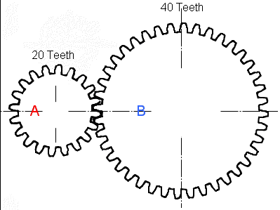

Eg. Consider an input gear with 20 teeth and an output gear with 40 teeth. You find the speed ratio by  
working out

$$i= \frac{driven or output gear}{driver or input gear}=\frac{40}{20}=2$$

40 ÷ 20 = 2. This pair of gears has a speed ration of 2, or 2/1. In other words, the input gear  
revolves twice to make the output gear revolve once. When you couple two gear wheels, their relative sizes determine how fast each will spin. If the driver wheel is smaller than the driven wheel, it will spin more often than the larger one. If the driver wheel is larger, the driven wheel will spin faster.

*Belt drive:*  
A belt is a looped strip of flexible material used to mechanically link two or more rotating shafts. A belt  
drive offers smooth transmission of power between shafts at a considerable distance. Belt drives are  
used as the source of motion to transfer to efficiently transmit power or to track relative movement.

*Types of Belt Drives:*

Open belt drives:  
An open belt drive is used to rotate the driven pulley in the same direction of driving pulley. In the  
motion of belt drive, power transmission results make one side of pulley more tightened compared to the  
other side.

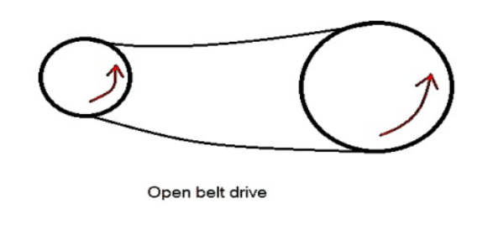

*Crossed belt drives:*  
A crossed belt drive is used to rotate driven pulley in the opposite direction of driving pulley. Higher the  
value of wrap enables more power can be transmitted than an open belt drive.

Advantages of belt drives:

1. Belt drives are simple are economical.
2. They don’t need parallel shafts.
3. Belts drives are provided with overload and jam protection.
4. Noise and vibration are damped out.

Disadvantages of belt drives:

1. In Belt drives, angular velocity ratio is not necessarily constant or equal to the ratio of pulley  
   diameters, because of slipping and stretching.
2. Heat buildup occurs. Speed is limited to usually 35 meters per second. Power transmission is  
   limited to 370 kilowatts, while Operating temperatures are usually restricted to –35 to 85°C.

*Chain drive*  
A chain drive consists of an endless chain wrapped around sprocket wheels. The chain has a number of  
links connected by pins. The sprockets have teeth of special profile. Chains are used for power  
transmission and as conveyors. The chain drives have some features of both belt (flexibility of location  
of driver and driven) and gear drives (ruggedness). They are classified into two types:

1. Roller Chains
2. Silent Chains

***Conclusion:***

The working and applications of various power transmitting devices was studied and understood. Gears are one the most commonly used power transmitting elements. A gear is a toothed wheel that engages with another toothed wheel or with a rack in order to change the speed or direction of transmit motion. The ratio  
of the turning speed of the output gear to that of the input gear, is known as the speed ratio, which was calculated for a set of 2 simple spur gears as,

Gear ratio,

$$i= \frac{driven or output gear}{driver or input gear}=\frac{40}{20}=2$$

*Exercises:*

1. Driver wheel has 40 teeth, and the driven wheel has 60, calculate the gear ratio and also calculate the RPM of driven wheel if the driver is rotating at 600 RPM

A. We know,

$$z_{1}=40, z_{2}=60, N_{1}=600 rpm$$

Therefore, Substituting the values, we get

$i = 60/40 =1.5$

And

$$\frac{N_{2}}{N_{1}}=\frac{Z_{1}}{Z_{2}}=\frac{40}{60}=0.66$$

$$N_{2}=0.66*N_{1}=0.66*600=400$$

1. Find the number of teeth required on driven gear to reduce the RPM by half, if number of teeth on driver gear is 80

A. We know,

$$z_{1}/z_{2}=N_{2}/N_{1}$$

$$z_{1}=80$$

*Let*

$$N_{1}=x, Then N_{2}=x/2$$

Substituting, we get

$$80/z_{2}=(x/2)=1/2$$

therefore, $z_{2}=80*2=160$

1. Suggest the type of gear used if two shafts are intersecting perpendicularly
   1. Bevel Gears can be used if two shafts are intersecting perpendicularly.